Health First

Requirements Document

Prepared by: Pat Stevens

Version: 0.6

Nov. 1, 2009

Health First Requirements Document

Table of Contents
1. Introduction 3
2. Scope 3
3. Overview 3
4. Requirements 5
5. U se Case Overview 6
5.1 Make Appointment 7
5.2 Retrieve/Update Patient Information 8
5.3 Create Patient Information 10
5.4 Determine Health Plan Eligibility 12
5.5 Treat Patient 15
5.6 Charge Patient 17
5.7 Submit Health Care Claim 17
5.8 Request Status on Care Claim 18
5.9 Request Authorization 20
5.10 Review Plan Payments 22

Table of Figures
Figure 3.1: Business Process Activity Diagram 3
Figure 5.1: Use Case Diagram 6
Figure 5.2: Patient Appointment Form 8
Figure 5.3: Patient Information Form 11
Figure 5.4: Patient Medical History Form 11
Figure 5.5: Patient Plan Management Form 13
Figure 5.6: Determine Health Plan Eligibility Form 14
Figure 5.7: Patient Medical Treatment Form 16
Figure 5.8 Submit Health Care Claim Form 18
Figure 5.9: Determine Health Care Claim Status Form 19
Figure 5.10: Certification and Authorization of Referrals Form 21
Figure 5.11: Health Plan Payments Form 23

Health First Requirements Document

Introduction
This document contains the requirements for the first release of the Health First Computer System, being developed by Kenosha Software Consulting. The system uses a database that tracks appointments, Patient information, health plan authorizations, and payments.

Scope
As part of the first release, some functions will be minimal. What is missing in particular is information related to HIPAA Security Rule requirements. As such, this product in its first release should not be included on a computer accessible to the internet or on a wireless network.

Overview
The main roles in a Patient visit include the Administrator and the Doctor.
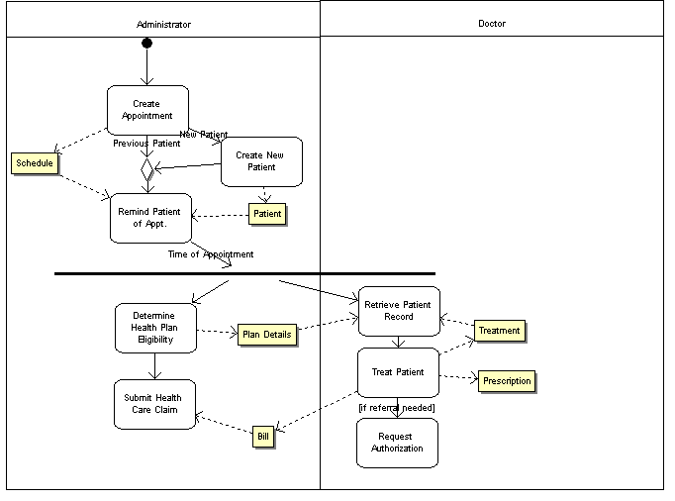
Figure 3.1: Business Process Activity Diagram
The Administrator will accept calls from Patients and make appointments with specific Doctors. If a new Patient calls, the Admin will create a new Patient record and record contact information and health provider information. The day before the appointment the Administrator reviews the Patient schedule for the next day and reminds all Patients. (If it is possible to automate the sending of email reminders, this would be a desirable feature.)
The day of the appointment, the Administrator fetches the plan eligibility information from the Health Plan about the Patient. These details are made available to the Doctor in a common shared directory, but deleted nightly. The Doctor then advises the Patient, updating Treatment and Prescription records. The Doctor may send in a bill directly to the Health Plan, or forward a record to the Administrator to submit. In some cases, the Doctor will request a referral from the Plan for the Patient to a Specialist Doctor.

Requirements
No. | Requirement | Type | Priority
1 | Patients can make appointments, via the Administrator, with a particular Doctor, date and time. An appointment can include multiple Patients. | Functional, Patient | Required
2 | Patients are notified of their appointment by email one day in advance. | Functional, Patient | Nice to have
3 | Information collected in the database about the Patient includes contact information, insurance information, family information (if in same medical plan), and medical history | Functional, Patient | Required
4 | Doctors can enter treatment information including diagnosis and treatment notes, prescriptions, and can save lab reports into the database. | Functional, Patient | Required
5 | Automated Health Plan transactions include:  Determine Health Plan Eligibility  Request Authorization/Referral  Determine Status of Health Care Claim | Functional, Plan Interface | Highly desired
6 | Automated Health Plan transactions include:  Submit Health Care Claim | Functional,  Plan Interface | Required
7 | The database must adhere to HIPAA requirements | NonFunctional  & Functional | Highly desired

Use Case Overview
The three actors that exist below include the Doctor, Administrator, and Health Plan. The Health Plan serves as an automated system actor, which is contacted automatically when certain forms are executed, in order to obtain Plan information, permission, or to submit a bill (or claim).
The Administrator is responsible for entering appointments into the system, as requested by the Patient, or Patient and Doctor. For new customers, basic customer information is collected at the time the first appointment is set up, in the ‘Create Patient Information’ use case.
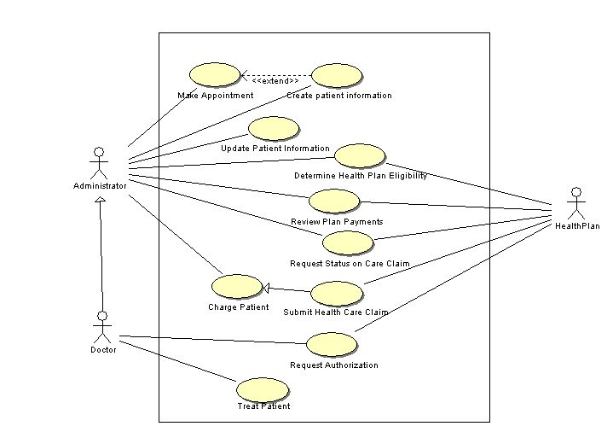

Figure 5.1: Use Case Diagram
When the Patient comes in for the appointment, a new Patient will need to complete the medical history form, which is entered by the Administrator in ‘Update Patient Information’. The Admin will then also request from the Health Plan the health plan eligibility information.
When the Doctor sees the Patient, the Doctor can Treat Patient, which can result in a diagnosis, treatment plan, new prescriptions, and a review of lab work. The Doctor can also request a referral to a specialist, if the Patient belongs to an HMO and a specialized practitioner is required.
The Doctor or Administrator can submit the Health Care Claim to the Health Plan. Later, the Administrator can review the status of the claim. Health Plans are requested to send confirmations when claims are paid. Payments are reviewed through the ‘Review Plan Payments’ use case.
The next section describes each of the use cases in detail, and shows prototype forms.

Make Appointment
Use Case: Make Appointment
Use Case ID: 1
Primary Actors:
Administrator
Doctor
Preconditions:
The User is logged in and at the main menu
Flow of Events:
- The use case begins when the user selects the Make Appointment menu
- The system displays the Make Appointment (Fig. 6.1) Form
- The user enters either a Doctor and a date or a Patient name
- If multiple Patients have the name
4.1 The system prompts for a first name and initial
- If the Patient name is entered and the system does not recognize the name
  - An error message: Patient name not recognized is displayed
  - The system reprompts for valid information
extension point: Create Patient Information
- The system displays the list of appointments for one day corresponding to the date entered or the next appointment for the Patient. The form displays times and names.
- The user can scroll up and down the page.
- The user can erase or add names to the page at the time desired, in the format: Last, First Initial. Multiple names can be included at one appointment time.
- The user can enter Submit to save the changes.
- The system displays a popup: “Appointments saved”

Alternate Flows:
none
Postconditions:
The appointment page is displayed for the desired search, and any new appointments are added or existing appointments changed or deleted.

Date
Doctor
9/5/2010
J. Ramon
TimePatient
AM
8 Stuart, John
8:30 Winfrey, Oprah
9
9:30
10
10:30
11
11:30
Patient Appointment
Patient name (Last, First):
Submit
Figure 5.2: Patient Appointment Form

Retrieve/Update Patient Information
Use Case: Retrieve/Update Patient Information
Use Case ID: 2
Primary Actors:
Administrator
Patient
Doctor
Preconditions: The user is at the main menu
Flow of Events:
- The use case begins when the user selects “Manage Patient”
- The user can enter last name and first name (and optionally middle initial) and press ‘Retrieve’.
- While the system cannot find a single matching record
  - The system displays an error message: “No Match” or “Multiple Entries”, and requests the user revise the information.
- The system retrieves the full Patient record as multiple tabs, including Patient Information (Form 6.2, Patient Medical History (Form 6.3), Patient Medical Information (Form 6.4), and if insured: Patient Plan Management (Form 6.5) or if not: Patient Bill Management.
- The user may modify Patient information and press ‘Save’
- The system displays the message “Record Saved”
Alternate Flows:
none
Postconditions:
- The Patient information is displayed, including Patient Information, Patient Medical History, Patient Medical Information, and Patient Plan or Bill Management.
- Any changes to the record have been updated

Create Patient Information
Use Case: Create Patient Information
Use Case ID: 3
Primary Actors:
Administrator
Doctor
Preconditions: The user is at the main menu.
Flow of Events:
- The user case begins when the user selects “Manage Patient” or as an extension to Make Appointment
- The user can enter last name and first name (and optionally middle initial) and press ‘Create’.
- While the system finds a matching record
  - The system displays an error message: “Match Exists”, and requests the user revise the information.
4. The system displays multiple tabs, including Patient Information (Form 6.2, Patient Medical History (Form 6.3), and Patient Medical Information (Form 6.4).
5. The system renames the ‘Create’ button into the ‘Save’ button.
6. The user enters information for the new Patient and presses ‘Save’.
7. The system displays: ‘Record Updated’
8. The system creates a Patient Plan Management (Form 6.5) tab for Patients with health plans, or a Patient Bill Management tab for Patients without.
Alternate Flows:
none
Postconditions:
1. The new record has been saved into the database.
2. For Patients with health plans, a Patient Plan Management tab is available with information about the Patient’s plan. For Patients without, a Patient Bill Management tab is provided.

Patient Information
Last Name:First Name:Middle or Initial:

Address:Phone:
City:Email:
State:

Family Members:

Employer:Address:
Insurance Plan:Group Number:

Last Visit:Doctor:
Next Visit:Doctor:
Retrieve
Create
Figure 5.3: Patient Information Form
Patient Medical History

Name:Birth Date:

Smokes: 1-5 times/wkDrinks alcohol: 1-5 times/wk

PatientDateFamily Member
Breast Cancer
Diabetes x1989Mother, Brother
Glaucoma
Heart Disease x 2004, 2008Father, Sister
Stroke

OperationsDateNotes
Appendix Removed8/2005

Figure 5.4: Patient Medical History Form

Determine Health Plan Eligibility
Use Case: Determine Health Plan Eligibility
Use Case ID: 4
Primary Actors:
Administrator
Doctor
Secondary Actor:
Health Plan
Preconditions:
The user has retrieved a Patient record. If the Patient is a member of a health plan, the Patient Plan Management tab exists.
Flow of Events:
- The use case begins when the user selects the tab: Patient Plan Management.
- The user selects the link: Determine Health Plan Eligibility
- The system requests information from the Health Plan automatically.
- The system brings up the Health Plan Eligibility Form, Form 6.6, displaying information for maximum benefit, co-pay, deductible, and information about specific procedures: procedure type, coverage dates, maximum coverage, co-pay, non-covered amounts.
- If the user selects more information on Exclusions, In-Plan Benefits, Out-of-Plan Benefits, or Coordination of Benefits by selecting the appropriate link.
5.1 The system displays a popup with the requested information.
Alternate Flows:
Plan Eligibility information not available
Postconditions:
- The Patient’s Health Plan Eligibility is displayed
- Extra information relating to Exclusions, In-Plan or Out-of-Plan or Coordination of Benefits is displayed as a popup, if requested.

Alternate Flow: Determine Health Plan Eligibility: Plan Eligibility Information Not Available
- The secondary scenario begins after step 3 of the Primary Scenario
- The system displays an error message appropriate to the communications failure type: “No connection” or “Connection Timed Out” or “Host not available” etc.
Postconditions:
A descriptive error message is displayed.

Patient Plan Management
Last Name:First Name:Middle or Initial:

Address:Phone:
City:Email:
State:

Employer:Address:
Insurance Plan:Group Number:

Determine Health Plan EligibilityRequest Authorization

Submit Health Care ClaimDetermine Status of Health Care Claim
DateDoctor ProcedurePricePaid
9/21/09 J Ramon Annual Checkup $120 $100
Figure 5.5: Patient Plan Management Form
Health Plan Eligibility

Health Plan:Eligibility: Active

Maximum Benefit:Co-Pay:Deductible:

Exclusions

In-Plan BenefitsOut-of-Plan Benefits Coordination of Benefits

Specific Procedure Request

ProcedureCoverageMax. CoverageCo-pay /Non-covered
DatesPatient Resp Amounts
Figure 5.6: Determine Health Plan Eligibility Form

Treat Patient
Use Case: Treat Patient
Use Case ID: 5
Primary Actors:
Doctor
Preconditions: The Patient record has been selected.
Flow of Events:
- The use case begins when the user selects the Patient Medical Information form (Form 6.4).
- The system displays all information currently available for the Patient, including for Prescriptions, Treatment Notes, and Lab Reports.
- For each new Prescription
  - The user selects New next to the Prescriptions
  - The system displays a popup menu requesting Prescription name, start and stop date, dosage, and comments.
  - The user enters the required information and presses Add.
  - The system displays the new information on the main form.
- For each new Treatment Note
  - The user selects New next to the Treatment Notes
  - The system displays a popup menu requesting notes.
  - The user enters the required information and presses Add.
  - The system displays the new notes, automatically including date and Doctor on the main form.
- For each new Lab Report
  - The user selects New next to the Lab Reports
  - The system displays a popup menu requesting location of a file or a button to scan.
  - The user either provides a directory and file name or puts a copy of the report on the scanner and presses Scan
  - The file is scanned if necessary and attached.
  - The system displays the date and name of the lab report on the main form.
- If the user double clicks on any detail line that was created that day
  - The system will display a form to edit the information.
Alternate Flows:
none
Postconditions:
1. A treatment record has been updated.

Patient Medical Treatment
Prescriptions

Treatment Notes

Lab Reports

PrescriptionStart/Stop DateDosageComments
DateDoctorReport
DateReport Type
New
New
New
Figure 5.7: Patient Medical Treatment Form

Charge Patient
Use Case: Charge Patient
Use Case ID: 6
Primary Actors:
Administrator
Doctor
Preconditions: The user has retrieved a Patient record. If the Patient is a member of a health plan, the Patient Plan Management tab exists.
- The use case begins when the user selects the tab: Patient Bill Management.
- The system brings up the Health Care Payment Form, (similar to Form 6.7) and automatically displays Patient name and date.
- For each Health Care Claim
  - The user selects New
  - The system creates a popup window requesting diagnosis, service provided, price, and any notes. (Drop down boxes exist for diagnosis and service provided).
  - The user minimally enters the diagnosis and service provided and selects Add
  - The system displays the new item on the Health Care Payment Form.
- The user selects the Print button to print a bill
- The user selects a payment button: Cash, Credit, Check, and enters the payment amount and payment details in a popup form and presses Submit
- The payment details are updated on the Health Care Payment Form
Alternate Flows:
none
Postconditions:
1. The customer has been given a bill.
2. The bill is paid and payment method is recorded.
3. The Health Care Payment Form displays all health care payment information.

Submit Health Care Claim
Use Case: Submit Health Care Claim
Use Case ID: 7
Parent ID: 6
Primary Actors:
Administrator
Doctor
Secondary Actor: Health Plan
Preconditions: The user has retrieved a Patient record. If the Patient is a member of a health plan, the Patient Plan Management tab exists.
Flow of Events:
- (o1) The use case begins when the user selects the tab: Patient Plan Management.
- (i2) The user selects the link: Submit Health Care Claim
- (o2) The system brings up the Health Care Claim Form, Form 6.7, and automatically displays Patient name, insurance, group no, and date.
- (3) For each Health Care Claim
  - The user selects New
  - The system creates a popup window requesting diagnosis, service provided, price, and any notes. (Drop down boxes exist for diagnosis and service provided).
  - The user minimally enters the diagnosis and service provided and selects Add
  - The system displays the new item on Form 6.7 Health Care Claim.
- (o5) The user presses Submit
- (o6) The system submits the claim to the Health Plan

Alternate Flows:
none
Postconditions:
1. The bill is submitted to the Health Plan.
2. A bill is recorded in the database

Health Care Claim: Professional

Patient Name:Date:

Insurance:Group No.

DiagnosisService ProvidedPriceNotes
New
Figure 5.8 Submit Health Care Claim Form

Request Status on Care Claim
Use Case: Request Status on Care Claim
Use Case ID: 8
Primary Actors:
Administrator
Doctor
Secondary Actor:
Health Plan
Preconditions: The user has retrieved a Patient record. If the Patient is a member of a health plan, the Patient Plan Management tab exists.
Flow of Events:
- The use case begins when the user selects the tab: Patient Plan Management.
- The user selects the link: Determine Status of Health Care Claim
- The system brings up the Health Care Claim Status Form, Form 6.8, displaying Patient name, insurance, and group number.
- The user enters a date or claim number (or both).
- The system requests the information from the Insurance Plan
- The system displays the Claim number, Date, and Status of the claim or the next later claim (if no date match).
- The user may select Next or Previous to see the status of the preceding and subsequent claims.
Alternate Flows:
Claim Status Information Not Available
Postconditions:
A set of claim records is available to be scrolled through. Each claim record shows the Claim number, Date and Status.

Alternate Flow: Request Status on Care Claim: Claim Status Information Not Available
- The secondary scenario begins after step 5 of the Primary Scenario
- The system displays an error message appropriate to the communications failure type: “No connection” or “Connection Timed Out” or “Host not available” etc.
Postconditions:
A descriptive error message is displayed.

Health Care Claim Status

Patient Name:Date:

Insurance:Group No.Claim No.

Status:
Next
Prev
Figure 5.9: Determine Health Care Claim Status Form

Request Authorization
Use Case: Request Authorization
Use Case ID: 9
Primary Actors:
Administrator
Doctor
Secondary Actor:
Health Plan
Preconditions: The user has retrieved a Patient record. If the Patient is a member of a health plan, the Patient Plan Management tab exists.
Flow of Events:
- The use case begins when the user selects the tab: Patient Plan Management.
- The user selects the link: Request Authorization
- The system brings up the Certification and Authorization of Referrals Form, Form 6.9, automatically displaying Patient name, insurance, and group number.
- The user may check any or multiple checkboxes from:
Request for Patient to be admitted to hospital
Request for Patient to receive surgery
Request for Patient to see specialist
- The user must enter the desired service in the Extended Service Request Details field.
- The user must enter the reason for the extended service in the Reason for Extended Service field, and presses Submit
- The system returns a message: “Request Submitted”.
Alternate Flows:
none
Postconditions:
1. A request for Certification or Authorization of Referral has been submitted to the Health Plan.
2. (A response, when it becomes available, can be retrieved using the Health Plan Eligibility form.)

Certification and Authorization of Referrals

Patient Name:

Insurance:Group No.

Request for Patient to be admitted to hospital

Request for Patient to receive surgery

Request for Patient to see specialist

Extended Service Request Details:

Reason for Extended Service:

Figure 5.10: Certification and Authorization of Referrals Form

Review Plan Payments
Use Case: Review Plan Payments
Use Case ID: 10
Primary Actors:
Administrator
Doctor
Secondary Actor:
Health Plan
Preconditions:
The User is logged in and at the main menu
Flow of Events:
- The use case begins when the user selects the Health Plan menu
- The system displays the Health Plan Payments (Fig. 6.10) Form
- The user selects a health plan from a drop down box and a start date
- The system requests the information from the Health Plan.
- The system displays the payments from the health plan, including for each payment: Patient Name, Treatment Date, Amt Paid, and Details. The total in payments is displayed in the Payments Received box.
- The user can scroll up and down the page.
Alternate Flows:
Plan Payment Information Not Available
Postconditions:
Payments from the Health Plan are retrieved and displayed.

Secondary Scenario: Review Plan Payments: Plan Payment Information Not Available
- The secondary scenario begins after step 4 of the Primary Scenario
- The system displays an error message appropriate to the communications failure type: “No connection” or “Connection Timed Out” or “Host not available” etc.
Postconditions:
A descriptive error message is displayed.

Health Plan Payments

Date(s):Health Plan:

Payments Received:

Patient NameTreatment DateAmt Paid Details
Figure 5.11: Health Plan Payments Form

